**Linux Permissions :**

Entities:

user : who creates or own a file/dir.

group : collection of user performing various OS operations.

other : Anyone apart form user or associated group is other.

U [user] G[group]

O[others]

Types of permissions :

Read : Where one can only view the things/content.

Write : Where one can read as well write the things/content.

Exec : Where one can has executable [to run] the things/content.

d rwx rwx r-x 2 devops devops 4096 Feb 3 07:24 permissions

Dir U G O no. User Group Size Date Time Content [Dir]

Hard Links

7 7 5

Permission Bits :

Read : 4

Write : 2

Exec : 1

rwx r-x -wx

7 5 3

**Assignment** :

- 1 Use Case :

Create 2 users devops and demo

Create a dir with 3 files into it [devops]

1 File : Only w for all entities

2 File : Only r for all entities

3 File : Only x for all extities

login demo user and try to alter permissions of this structure.

Assign demo to devops group

**Create 2 users devops1 and demo1:**

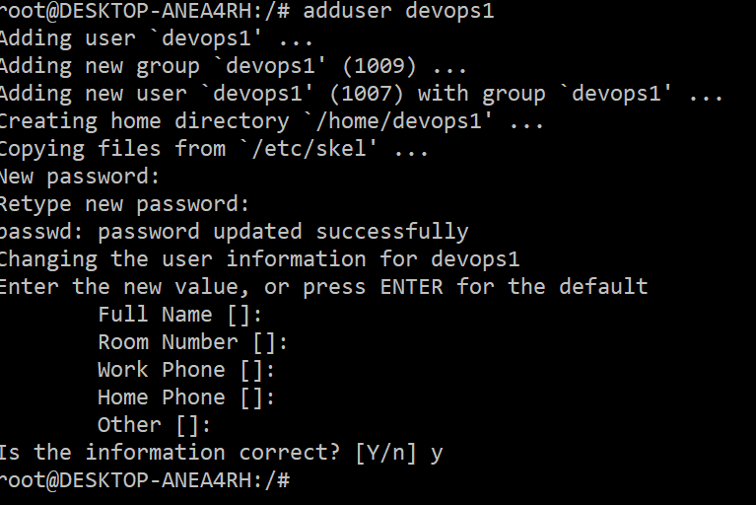

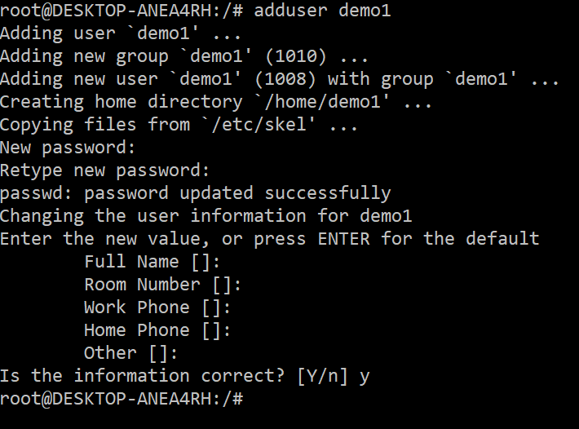

**Creating 3 files into devops1**

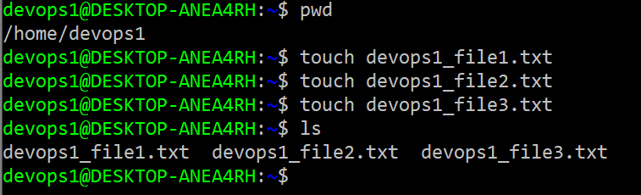

**Change the permission of all file Read Write Execute from devops1.**

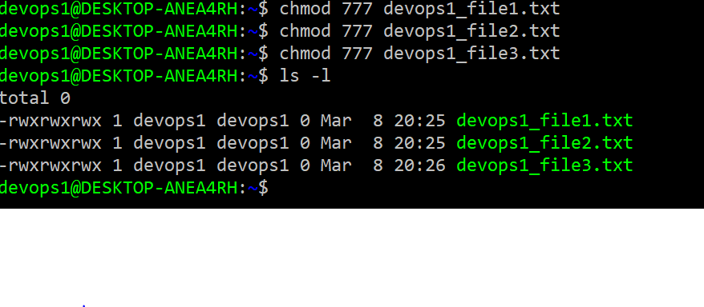

**login demo1 user and try to alter permissions of this structure.**

